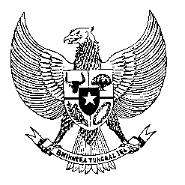

Permanent Mission

of the Republic of Indonesia to the UN, WTO,

and Other International Organizations

in Geneva

**STATEMENT BY THE PERMANENT REPRESENTATIVE OF THE REPUBLIC OF INDONESIA**

**AT THE 44th SESSION OF THE UPR WORKING GROUP - CONSIDERATION OF THE UPR REPORT OF THE RUSSIAN FEDERATION**

**13 NOVEMBER 2023**

**Madam Vice-President**

Indonesia thanks the delegation of the Russian Federation for their report.

We acknowledge the efforts the Russian Government made to expand employment opportunities for women and the progress in providing free education, including the inclusive education of children with disabilities.

We also recognize the ongoing efforts to prevent discrimination on social, racial, ethnic, linguistic, or religious grounds to ensure national unity.

In a constructive spirit to support the full realization of human rights in the Russian Federation, Indonesia offers the following recommendations:

1. Continue to strengthen the implementation of the UNCAT through improving legislation in the area of combatting torture, degrading treatment, and punishment;
2. Take further measures to increase employment opportunities for women, people with disabilities and promote their recruitment;
3. Continue to improve detention conditions and guarantee the rights of suspects, accused, and convicted persons.

Finally, we wish the Russian Federation delegation a very successful review.

Thank you.

*Word count: 152*

*Speaking time: Max 1 minute.*