***Check Against Delivery***

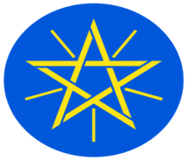

**Statement**

**by**

**the Representative of the Federal Democratic Republic of Ethiopia on the Universal Periodic Review of the Russian Federation**

**13 November,2023**

***Mr. President,***

Ethiopia **warmly** welcomes the delegation of the **Russian Federation** to the 44th Session of the UPR Working Group of the Human Rights Council. We thank the delegation for the comprehensive report and the oral update today.

Ethiopia commends **the Russian Federation** for implementing the recommendations received during the previous UPR cycles.

Ethiopia also welcomes the measures taken by **the Russian Federation** to promote and protect the human rights of all citizens, including women, youth, children, and persons with disabilities.

In a sprite of constructive engagement and dialogue, **Ethiopia recommends to the delegation of the** **Russian Federation:**

1. to continue to enhance the cooperation with international Partners in the human rights field,
2. to continue to introduce information technologies in the human rights education, and
3. to continue efforts to provide the support for victims of domestic violence.

Finally, Ethiopia wishes a successful engagement to the delegation of the **Russian Federation** in its engagement with the UPR Working Group.

***I thank you.***