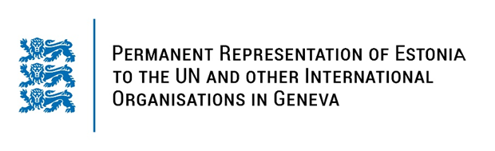

**Universal Periodic Review of the RUSSIAN FEDERATION**

**13 November 2023**

**Intervention by the delegation of Estonia**

Estonia takes note of the national report of the Russian Federation.

We condemn in the strongest possible terms Russia’sunprovoked and unjustified war of aggression against Ukraine and demand Russia to cease it. Russia is grossly violating international law, including the UN Charter, and international human rights law, includingthe right to life.

We remain deeply concerned by the continuous deteriorating human rights situation in Russia and its reckless disregard for the international commitments it has signed up to.

We recommendto Russia to:

- guarantee thorough, effective, independent and impartial investigations of human rights violations and war crimes committed by its armed forces in connection with the war of aggression against Ukraine;

- cooperate fully with all international human rights monitoring mechanisms and UN special procedures, including with the Special Rapporteur on the situation of human rights in the Russian Federation, and to ensure their unrestricted access throughout Russia;

- repeal the laws and provisions unduly restricting freedom of opinion and expression and the freedom of peaceful assembly, including laws on “foreign agents”, “undesirable” organizations, “extremist activity” and all provisions criminalizing so-called „fake news“;

- adopt measures to implement the judgments of the European Court of Human Rights against Russia, including criminalization of domestic violence with effective and dissuasive sanctions.

I thank you.