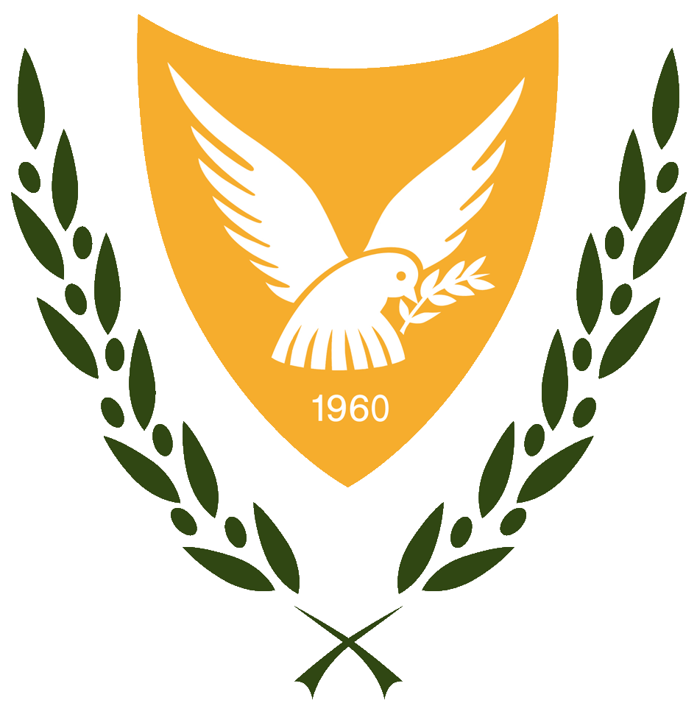

**Permanent Mission of the Republic of Cyprus**

**Geneva**

*G. Samouel*

**Intervention by Cyprus**

**13 November 2023, 14:30-18:00**

**Universal Periodic Review**

**44th Session**

**Russian Federation**

Mr. President,

Cyprus welcomes the delegation of the Russian Federation and thanks for the presentation of its report.

We remain extremely concerned by the severe deterioration of the situation of human rights in the Russian Federation, and the essential shut down of civic space. This trend has been exacerbated following Russia’s illegal war of aggression against Ukraine with the adoption of laws criminalizing anti-war speech and protest.

Cyprus recommends to the Russian Federation to:

1. Ratify the Istanbul Convention;
2. Fully engage with all UN human rights mechanisms;
3. Take measures to combat all forms of social stigmatization of, and hate speech, discrimination and violence against, persons based on their sexual orientation or gender identity, and ensure that such cases are investigated;
4. Refrain from any form of harassment, and review the detention of all journalists, media workers, human rights defenders, cultural figures, lawyers and political opposition representatives with regard to the compatibility of their detention with international human rights law.
5. Fix the minimum age of marriage to 18 in all its territory without any exceptions;

Thank you.