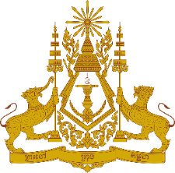

**PERMANENT MISSION OF THE KINGDOM OF CAMBODIA**

**TO THE UNITED NATIONS AT GENEVA**

**Statement of Cambodia**

At the 44th Session of the UPR Working Group

UPR of the Russian Federation

13 November 2023

-------

Madame Vice President!

1. Cambodia welcomes the delegation of the Russian Federation and thanks for comprehensive presentation of its national report.
2. We commend efforts taken by the government of the Russian Federation to promote and protect the rights of its people including their economic, social and cultural rights.
3. In the constructive spirit, Cambodia would like to put forward following recommendations:

* Continue implementing its national strategy to further expanding opportunities for participation in the country’s socio-economic life of Persons with Disabilities;
* Continue its efforts to implement effective measures to further improving quality of life for senior citizens.

1. Finally, I wish the delegation of the Russian Federation a successful review.

Thank you!

*\*\*\*\*\**