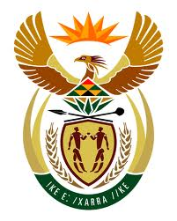

**SOUTH AFRICAN PERMANENT MISSION**

**TO THE UNITED NATIONS**

**AND OTHER INTERNATIONAL ORGANISATIONS**

**44TH SESSION OF THE WORKING GROUP ON THE**

**UNIVERSAL PERIODIC REVIEW**

**Review of GERMANY**

**09 NOVEMBER 2023**

**(55 Seconds)**

**speaker no: 59**

***Check against delivery***

Mr. President,

South Africa welcomes the distinguished delegation of Germany to this UPR Session and wishes the country a successful review.

South Africa commends Germany for the development of the ‘Guidelines for Shaping Feminist Foreign Policy’, which demonstrate its commitment to reinforcing the rights of women. We acknowledge the steps taken to strengthen the Federal Anti-Discrimination Agency, together with the commitment to undertake the reform of the General Equal Treatment Act to address any protection gaps.

South Africa wishes to make the following recommendations:

* Strengthen efforts to increase the number of women in decision-making bodies;
* Explicitly integrate mandatory gender-responsive budgeting into the federal budget;
* Consider an amendment to the Basic Law by replacing the word “race” in Article 3(3) with “racist discrimination” in order to facilitate protection in line with international human rights law; and
* Systematically monitor the implementation of measures adopted to combat racism and right-wing extremism and tackle any resistance to addressing structural and institutional racism in state authorities.

I thank you.