Jamhuuriyadda Federaalka Soomaaliya  Ergada Joogtada Soomaliyeed ee Qaramada Midoobey ee Geneva | 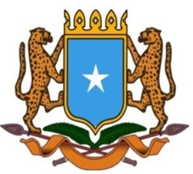 | جمهورية الصوما ل الفيدرالية  البعثة الدائمة لجمهورية الصومال بمكتب الأمم المتحدة بجنيف وبالوكالات المتخصصة بسويسرا

Permanent Mission of the Federal Republic of Somalia to the United Nations Office at Geneva and other International Organizations in Switzerland

Check Against Delivery
Statement by the Delegations of Somalia,
Amb. Ebyan Mahamed Salah
at the Review of the Federal Republic of Germany, during the 44th Session of the UPR Working Group on Thursday, 09 November, 2023 from 09:30 AM to 12:30 PM, in the Room XX of the Palais des Nations in Geneva, Speaker Number 58,
Time: 00 minute and 55 seconds.
Thank you Mr. President,

Somalia welcomes the delegation of the Federal Republic of Germany and commends its genuine committment to the UPR mechanisn as well as the progress achieved in the field of Human Rights since last review.

Somalia recommends to Gemany the following:

- Ratifying the International Convention on the Protection of the Rights of All Migrant Workers and Members of their Families (CRMW).

- To take effective Legal and administrative measures with a view to prevent and to combat all forms of discrimination, including Islamophobia and the practice of racial profiling by the police.

- To promote the economic empowerment of rural women and ensure that they had access to landownership and financial credit.

Finally, Somalia wishes Germany every success in this review.

I thank you Mr. President.

