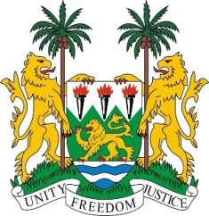

**SIERRA LEONE**

**44th Session of the UPR**

**GERMANY STATEMENT**

Thursday, 9th November 2023

**Mr. President**,

Sierra Leone welcomes and thanks **Ms. Luise AMTSBERG, MP, Federal Government Commissioner for Human Rights Policy and Humanitarian Assistance, Federal Foreign Office** and the distinguished delegation from Germany and thanks it for the presentation of its national report.

Sierra Leone commends Germany's increased provision of official development assistance, including support to the Office of the High Commissioner for Human Rights, and notes the tremendous impact of this assistance.

My delegation also welcomes the measures taken since the second reporting cycle to adopt further safeguards to ensure that asylum seekers are not returned to countries where they will face persecution, but notes that improvements can still be made in extending protections to persecuted religious minorities.

In a spirit of constructive engagement, we recommend the following for Germany`s consideration:

1. Consider ratifying the International Convention on the Protection of the Rights of All Migrant Workers and Members of Their Families.
2. Ensure the timely and transparent implementation of the measures to combat racism and extremism that were adopted by the federal government in 2021, and continue to build on this initiative.
3. Develop comprehensive reporting mechanisms for hate crimes, and increase efforts to prevent, investigate and sanction such incidents.

Sierra Leone wishes Germany every success in completing its fourth review cycle.

Thank you, Mr. President