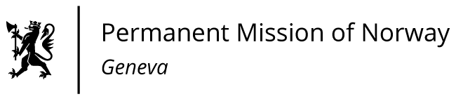

**STATEMENT**

**44th UPR Session of the Human Rights Council**

**on the human rights situation in Germany,**

**as delivered by Mr Tormod C. ENDRESEN**

**Ambassador - Permanent Representative to the UN and other International Organizations.   
The Permanent Mission of Norway in Geneva.**

Check against delivery

9 November 2023

President,

Norway welcomes the German delegation.

We commend the decision of the German Bundestag in 2022 to remove the ban on informing about abortions.

However, in an ever more polarised world, we share the concern about the rising number of reported hate crimes in Germany.

Norway recommends that Germany:

1) Takes further steps to strengthen prevention, investigation and prosecution of hate crimes, including by fully implementing the action plans on right-wing extremism and racism respectively, and by systematically monitoring the implementation and effect of measures adopted in the area;

2) Takes steps to provide [women and men with] equal opportunities in the labour market, including addressing the gender participation gap by improving the availability of childcare as one example;

3) Adopts a comprehensivestrategy for the implementation of the Istanbul Convention that addresses shortcomings in provisions of support and protection for survivors of violence and abuse;

4) Takes concrete steps to improve accessibility of public facilities and services for persons living with disabilities in line with Article 9 of the UN CRPD, including by enhancing monitoring of the implementation of existing national legislation. Thank you.