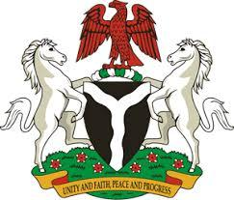

*Please check against delivery*

**HUMAN RIGHTS COUNCIL**

**44TH SESSION OF THE WORKING GROUP OF THE UPR OF THE REPUBLIC OF GERMANY**

**STATEMENT BY NIGERIA**

**9TH NOVEMBER, 2023**

**Mr. President,**

Nigeria welcomes the delegation of Germany to the presentation of its National Report and commends the Government for its commitment to its international human rights obligations and continued cooperation with human rights mechanisms .

2. We applaud the German Government for its dedicated efforts to protect children from trafficking, sexual exploitation and all forms of violence and abuse, through the establishment of the National Council on Combating Sexual Violence against Children and Young People. We further take positive note of the onerous efforts of the Government to promote gender equality, including policies devoted to closing gender pay gaps and addressing gender-based violence.

3. While acknowledging various efforts by the Government of Germany to promote human rights, Nigeria would like to make the following recommendations for consideration by Germany:

1. To sustain and scale up its efforts towards combating racism and discriminations in all its forms;
2. To consider further necessary measures to ensure the protection of the rights of migrants and refugees, including through the ratification of the Convention on the Protection of the Rights of all Migrant Workers and Members of their Families; and
3. To respect the rights of parents to raise and educate their children, in accordance with International law.

4. Finally, we wish Germany a very successful review process.

I thank you Mr. President.

******