*Check against delivery*

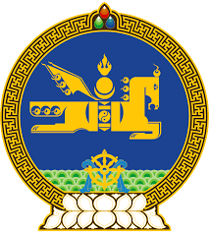

**44th SESSION OF THE UPR WORKING GROUP**

**MONGOLIA’S STATEMENT AT THE REVIEW OF THE**

**FEDERAL REPUBLIC OF GERMANY**

**9 November 2023**

Mongolia warmly welcomes and thanks the delegation of Germany for the presentation of their fourth national report.

Mongolia commends Germany for ratifying the Optional Protocol to the International Covenant on Economic, Social and Cultural Rights.

My delegation welcomes its establishment of the National Council on Combating Sexual Violence against Children and Young People in 2019, and the launch of the nationwide awareness-raising campaign for action on sexual violence against children and young people thereof.

Mongolia seizes this opportunity to recommend the Federal Republic of Germany to continue to ensure the effective implementation of its Gender Equality Strategy.

I thank you, Mr. President.

---oOo---