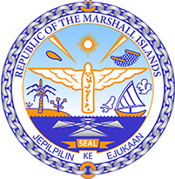

Republic of the Marshall Islands
STATEMENT by Mr. Samuel Lanwi Jnr
44th Session Universal Periodic Review
6th – 17th November 2023
Geneva

4th Cycle Review of Germany

The Marshall Islands welcomes the delegation of Germany and wishes them every success during its 4th UPR cycle. We appreciate and have enjoyed Germany’s support to our climate initiatives in the Human Rights Council and we welcome their efforts to renew the Geneva Pledge.

With the fast-closing window to keep the 1.5ºC goal of the Paris Agreement alive, we urge everyone to recall that for those most vulnerable it is “1.5 to survive”. Among the many human rights impacted by climate change, the very right to life of the most vulnerable is at stake.

In a constructive spirit, we offer to Germany the following 2 recommendations:

- Take urgent action to strengthen its NDC targets, and its Federal Climate Protection Act to ensure its emissions remain within the 1.5ºC goal.

- Take all the necessary steps to implement the findings of the 24 March 2021 ruling of the Federal Constitutional Court.

We look forward to Germany’s continued leadership on climate change and human rights.

Kommol tata and I thank you Mr. President.

