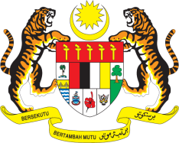

**STATEMENT BY MALAYSIA**

**REVIEW OF GERMANY**

**44TH SESSION OF THE UPR WORKING GROUP**

**6 – 17 NOVEMBER 2023**

Madam President,

Malaysia welcomes the delegation of Germany to this UPR session and commends the Government’s strong commitment to the promotion and protection of human rights.

1. Malaysia **recommends** Germany to intensify efforts to effectively implement and enforce existing legislation against racism including taking the necessary measures to protect children from all forms of discrimination, intolerance, racist hate speech, racist violence and other hate crimes.
2. We further **recommend** Germany to combat racism against migrants through training programmes for the police and collaboration with the media on awareness-raising campaigns.
3. Germany’s efforts to address gender-based violence against women are commendable. We **recommend** Germany to intensify efforts to prosecute perpetrators of violence against women and girls.

Malaysia wishes Germany a successful review.

Thank you.

**9 NOVEMBER 2023**

**GENEVA**