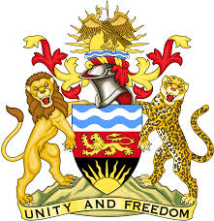

**REPUBLIC OF MALAWI**

**MALAWI STATEMENT ON THE FEDERAL REPUBLIC OF GERMANY UNIVERSAL PERIODIC REVIEW**

**THURSDAY, 9TH NOVEMBER 2023**

**Mr. President**,

Malawi welcomes the Federal Republic of Germany to this review and thanks the delegation for the comprehensive presentation.

Malawi commends Germany’s efforts in adhering to the recommendations made in the third UPR cycle through the ratification of the ILO Protocol of 2014 to the Forced Labour Convention and the completion of the legislative process on the Optional Protocol to the International Covenant on Economic, Social and Cultural Rights.

In the spirit of constructive dialogue, Malawi makes the following recommendations to Germany:

1. Systematically monitor implementation of the 89 measures to combat racism and extremism that were adopted by the Federal Government in 2021;
2. Strengthen efforts to incorporate children’s rights explicitly into the Basic Law; and
3. Develop comprehensive reporting mechanisms for hate crimes, and increase efforts to prevent, investigate and sanction such incidents.

We wish the Federal Republic of Germany all the best at this review.

**Thank you, Mr. President**.