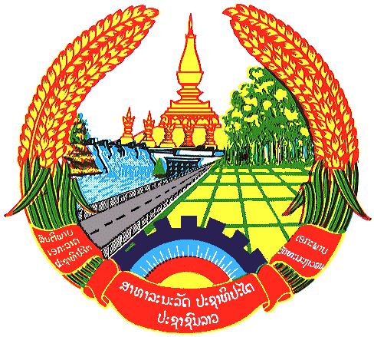

**Statement by the delegation of the Permanent Mission of the Lao PDR to the United Nations and other International Organizations in Geneva**

**at the 44th Session of UPR Working Group**

**Geneva, 9 November 2023**

Review of Germany (09:00 - 12:30)

1. Thank you, Mr. President, for the floor.
2. My delegation warmly welcomes the delegation of Germany and thanks for the presentation of the national report.
3. The Lao PDR welcomes the continued contribution of Germany in international cooperation and development assistance. We also commends Germany for the progress made in strengthening the promotion and protection of the rights of vulnerable groups, including women, children, migrants and persons with disabilities.
4. In this constructive spirit, the Lao PDR would like to make following recommendations:

* Strengthen national efforts to ensure the full implementation of the Gender Equality Strategy.
* Continue to extend the international cooperation and international development assistance to broaden the implementation of Sustainable Development Goals (SDGs).

1. We wish Germany every success in this UPR cycle review.
2. I thank you, Mr. President.