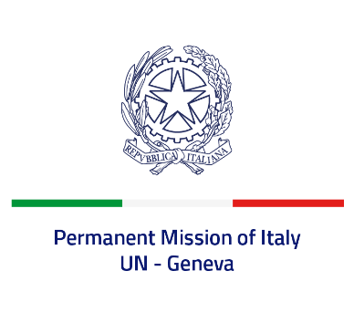

*Check against delivery*

**UPR 44 – Germany**

**Thursday 9 November 2023, 9:00 – 12:30**

**Delivered by: Permanent Representative of Italy Amb. Vincenzo Grassi**

*(Focal point: Daniele Borrelli, First Counsellor)*

Thank you, Mister President.

We thank the distinguished delegation of Germany for their national report and presentation.

Italy commends Germany for its commitment to ensuring the protection and promotion of human rights globally as a current member of the *Human Rights Council* as well as within the framework of other international and regional fora.

We also welcome the recent ratification of the *Optional Protocol to the International Covenant on Economic, Social and Cultural Rights* and the increased efforts to prevent and combat violence against women and domestic violence.

Italy would like to recommend to:

* *Strengthen efforts to combat racial discrimination and racial profiling in law enforcement activities.*

We wish the delegation of Germany a successful review.

I thank you.