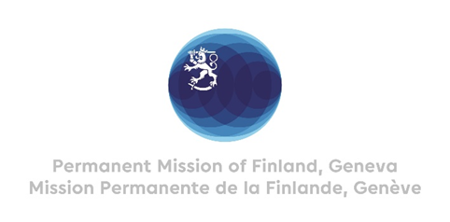

**44 Session of the UPR working group**

**Recommendations by Finland to Germany**

**9th November 2023**

Mr. President,

Finland welcomes the engagement of Germany in the UPR. Finland commends Germany for developing the federal government’s gender equality strategy further.

Finland recommends:

1. First, to combat all forms of violence against and enhance protection of all women and girls, including by increasing the number of shelters and financial resources to support victims and survivors,
2. Second, to promote gender equality by taking further measures to provide equal opportunities in the labour market, by improving the availability, affordability and quality of childcare,
3. Third, to address hate speech by increasing public resources for awareness-raising aimed at promoting respect for human rights, tolerance for diversity and eradicating stereotypical prejudices.

Thank you.