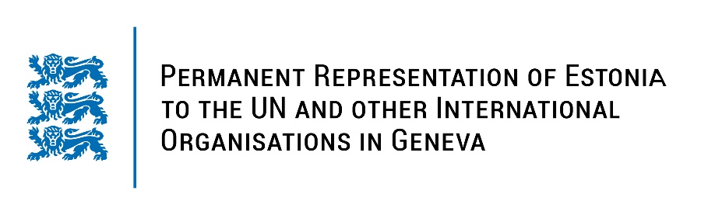

**Universal Periodic Review of GERMANY**

**9 November 2023**

**Intervention by the delegation of Estonia**

Estonia warmly welcomes the delegation of Germany to its fourth UPR and thanks for the comprehensive report and its presentation today.

Estonia appreciates Germany’s active role as a member of the UN Human Rights Council and in promoting and protecting human rights globally. Estonia praises Germany for its steps and strategies for gender equality, including narrowing the gender pay gap and addressing gender-based segregation in the labour market.

We positively note Germany’s solidarity it has shown in receiving refugees and for assuring them valuable protection.

Estonia recommends the Federal Government of Germany to:

- develop a comprehensive prevention strategy to address domestic violence;

- continue efforts to dismantle discriminatory gender stereotypes and structural barriers which are deterring girls from choosing so called non-traditional fields of studies, such as science, technology, engineering and mathematics.

Estonia wishes to the delegation of Germany all success in the current review and in implementing the recommendations.

Thank you!