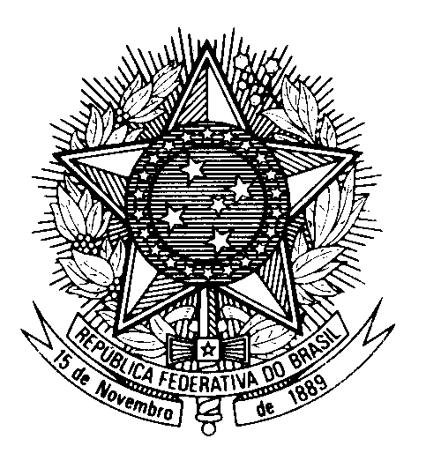

Review of Germany during the

44th session of the Working Group on the Universal Periodic Review Statement of Brazil

(Geneva, 9 November 2023)

Mister President,

Brazil commends Germany for the ratification of ILO Convention 169 and the expansion of children´s rights.

However, we remain concerned about continued allegations of discrimination of vulnerable children.

Brazil recommends Germany to:

1) Adopt measures to ensure German corporations respect human rights standards when operating abroad, including by establishing an independent mechanism to investigate abuses;

2) Redouble efforts to erradicate structural racism and discrimination in schools, including through collaboration with the media on awareness-raising campaigns.

We commend the country´s decision to return to Cameroon, Namibia, and Nigeria items collected in the colonial context.

We also congratulate Germany for its efforts and leadership in promoting the right to privacy.

Thank you.

