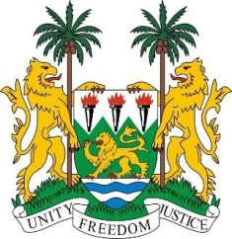

**Mr. President,**

Sierra Leone welcomes **H.E Mr. Bruno Rodriguez Parilla, Minister of Foreign Affairs** and the distinguished delegation from Cuba and thanks it for the presentation of its national report.

Sierra Leone welcomes Cuba's commitment to free universal primary health care and education. We welcome the establishment of the National Programme against Racism and note in particular the establishment of a National Commission mandated to monitor measures to combat and eradicate racism, discrimination and other forms of intolerance.

We also welcome the adoption of a new Constitution in 2019, which guarantees and expands fundamental human rights and strengthens an equality clause and non-discrimination.

In support of the Government's initiatives to address systemic racism and discrimination, we offer the following recommendations:

1. Invest in research into racial inequalities in different areas such as health, education, and employment.
2. Demonstrate political will to address racism at the highest levels of government and advocate for inclusive policies and practices that prioritise racial equality.
3. Create platforms for individuals to share their experiences and perspectives and maintain an ongoing dialogue on racial issues within society to address emerging challenges.

Sierra Leone wishes Cuba every success in the completion of its fourth review cycle.

I thank you