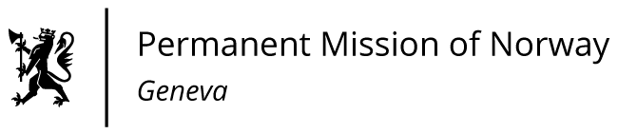

**STATEMENT**

**4thrd UPR Session of the Human Rights Council**

**on the human rights situation in Cuba,**

**as delivered by Mr Martin TORBERGSEN**

**Minister Counsellor, Human Rights,   
Permanent Mission of Norway in Geneva.**

Check against delivery

15 November 2023

Mr. President,

Norway commends Cuba for making important progress in the legislation to further ensure judicial protection of women, children and LGBTI+ persons in the new family code from 2022.   
  
However, we remain concerned regarding the human rights situation in general, and the civil and political rights in particular.

Norway recommends Cuba to;

1. ratify the ICCPR and the ICESCR without reservations;

2. create a safe and enabling environments for all civil society,   
human right defenders and independent journalists;

3. refrain from using the new Penal Code to criminalize civil society actors and individual voices critical of the authorities;

4. ratify the second Optional Protocol of the ICCPR aiming at the abolition of the death penalty.

I Thank you.