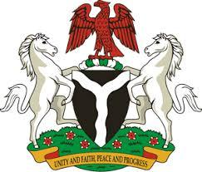

*Please check against delivery*

**HUMAN RIGHTS COUNCIL**

**44TH SESSION OF THE WORKING GROUP OF THE UPR OF THE REPUBLIC OF AZERBAIJAN**

**STATEMENT BY NIGERIA**

**15TH NOVEMBER, 2023**

**Mr. President,**

Nigeria welcomes the delegation of the Republic of Azerbaijan to the presentation of its National Report and commends the Government for its commitment to international human rights obligations and continued cooperation with human rights mechanisms.

2. We take positive note of the onerous efforts by the Government of Azerbaijan to promote gender equality, including wage reforms to eliminate the wage gap between men and women.

3. While recognizing the genuine efforts and commitment of the Government of Azerbaijan to promote and protect human rights, Nigeria wishes to recommend for Azerbaijan :

1. To intensify efforts towards reducing maternal and child mortality, increasing safe births, prevent infections during pregnancy and providing quality medical care for Newborns; and
2. To consider taking further necessary measures to ensure the elimination and prevention of violence against women and children.

4. We wish Azerbaijan a very successful review process.

**I thank you, Mr. President**.