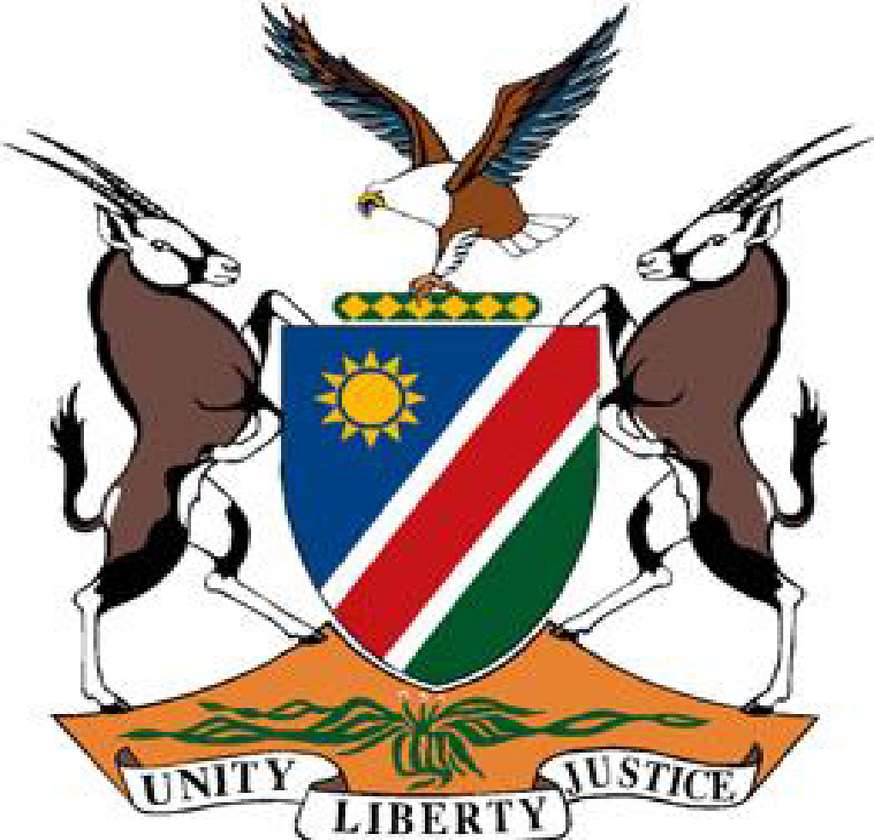

Statement by H.E. Julia Imene-Chanduru, Ambassador/ Permanent Representative, Fourth UPR Cycle of Cuba, 14 November 2023.

1. **Thank you, Mr. President,**
2. Namibia warmly welcomes the Esteemed Delegation of Cuba. We congralute them for the comprehensive presentation of their national report outlining the numerous positive human rights impact measures taken during the period under review. While applauding these measures we reiterate our call for the lifting of the 61 year old illegal economic, commercial and financial blockade imposed on the Cuban government and its people.
3. Namibia recommends the following for consideration by Cuba:

1. Establish an independent national human rights institution in accordance with the Paris Principles;

2. Continue with efforts to implement the Family Code and operationalize the Family Ombudsman's Office established in 2023.

1. **I thank you Mr. President.**