*Check against delivery*

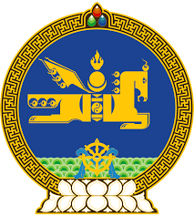

**44th SESSION OF THE UPR WORKING GROUP**

**MONGOLIA’S STATEMENT AT THE REVIEW OF CUBA**

**15 November 2023**

Mongolia warmly welcomes the delegation of Cuba to the 4th cycle of the UPR process and thank them for the presentation of their national report today.

Mongolia congratulates Cuba and the friendly people of Cuba on the adoption of its new Constitution in 2019, welcomes the subsequent legislative reforms and encourages their further strengthening.

My delegation is pleased to note Cuba’s continued and effective efforts in safeguarding the rights especially that of persons of vulnerable groups through inclusive high-quality health and education services.

Mongolia would like to make the following recommendations to Cuba:

* To ratify the International Covenants on Civil and Political Rights and on Economic, Social and Cultural Rights;
* To establish its national human rights institution in accordance with the Paris principles; and
* …...

We wish the delegation of Cuba every success in its review.

I thank you, Mr. President.

---oOo---