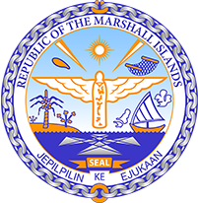

Republic of the Marshall Islands
STATEMENT by Mr. Samuel Lanwi Jnr
44th Session Universal Periodic Review
6th – 17th November 2023
Geneva

4th Cycle Review of Cuba

Mr. President,

The Marshall Islands welcomes the delegation of Cuba. We commend Cuba on its efforts to ensure disaster preparedness by continuing to strengthen its early warning system and the high priority given to the protection of its people from disasters.

We further commend Cuba for its recognition of new human rights through its 2019 Constitution, including the right to water, the right to healthy and adequate food, he right to water; the right to a safe and healthy habitat; and to a healthy and balanced environment, among others.

We recommend as follows:

- Ratify the International Covenant on Civil and Political Rights.

- Ratify the International Covenant on Economic, Social and Cultural Rights.

Kommol tata and thank you Mr. President.

