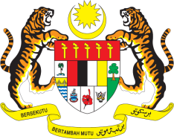

**STATEMENT BY MALAYSIA**

**REVIEW OF CUBA**

**44TH SESSION OF THE UPR WORKING GROUP**

**6 – 17 NOVEMBER 2023**

Thank you Mr. President / Mr./Madam Vice President.

1. Malaysia thanks Cuba for the presentation of its national report and would like to recommend the following:
   1. Take proactive steps to raise awareness about the provisions of the Convention on the Rights of the Child and its protocols among the stakeholders;
   2. Continue taking the necessary measures to facilitate the participation of elderly and persons with disabilities in electoral and decision-making processes; and
   3. Step up the protection measures for workers’ rights by fulfilling its obligation under the ILO Convention.
2. We wish Cuba a successful review.

Thank you.

**15 NOVEMBER 2023**

**GENEVA**