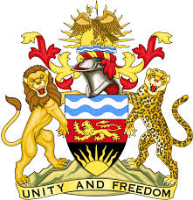

**REPUBLIC OF MALAWI**

**MALAWI STATEMENT ON THE REPUBLIC OF CUBA UNIVERSAL PERIODIC REVIEW**

**WEDNESDAY, 15TH NOVEMBER 2023**

**Mr. President**,

Malawi welcomes Cuba to this review and thanks the delegation for the comprehensive presentation. Malawi takes note of the country’s commitment to the promotion and protection of human rights as evidenced by the adoption of the National Programme against Racism and Racial Discrimination in 2019 and the National Programme for the Advancement of Women in 2021.

In the spirit of constructive dialogue, Malawi makes the following recommendations to Cuba:

1. Continue implementing laws and policies for the total elimination of racial discrimination.
2. Develop a gender strategy in the legal system to promote a cross-cutting approach to the elimination of stereotypes in the drafting and interpretation of legal regulations.
3. Systematically improve social protection and welfare programs for the benefit of vulnerable groups such as persons with disabilities and their families.

We wish Cuba all the best at this review and in the implementation of the recommendations.

**Thank you, Mr. President**.