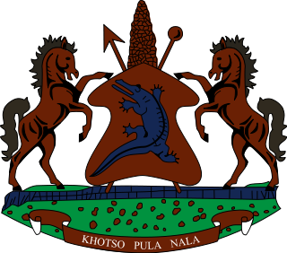

**INTERVENTION OF THE DELEGATION OF LESOTHO DURING THE 4th UPR CYCLE OF CUBA**

**15 NOVEMNER 2023**

**GENEVA, SWITZERLAND**

Thank you Mr. President,

Lesotho welcomes the distinguished delegation of Cuba to the 44th session of the UPR Working Group. We welcome efforts made by Cuba to guarantee the right to equality and freedom from discrimination, by incorporating chapter 8 into the new Criminal Code; the chapter of which addresses all forms of discrimination or differentiation that might impair human dignity.

Despite these positive developments, Lesotho wishes to make the following 3 recommendations for consideration by Cuba 1. To ratify ICCPR and ICERD; 2. To ensure the full respect of the freedom of expression, association and assembly by law enforcement agencies; and lastly, to redouble efforts to fight gender base violence.

We wish Cuba every success with this UPR cycle

THANK YOU