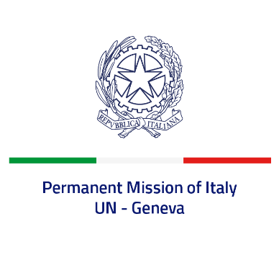

*Check against delivery*

**UPR 44 - Cuba**

**Wednesday 15 November 2023, 9:00 - 12:30**

**Delivered by: Ambassador Vincenzo Grassi, Permanent Representative of Italy**

*(Focal point: Angela Zanca, First Secretary)*

Thank you, Mister President.

Italy welcomes the promulgation of the new Cuban Constitution in 2019 and recognizes the efforts made by the Cuban Government to improve the normative and institutional framework for the protection of human rights.

Italy seizes this opportunity to offer Cuba the following recommendations:

* *Consider ratifying the International Covenant on Civil and Political Rights and the International Covenant on Economic, Social and Cultural Rights;*
* *Fully abolish the death penalty;*
* *Guarantee freedom of opinion and expression, online and offline, and the right to peaceful assembly;*
* *Safeguard the free and independent activity of human rights defenders and journalists, without any prejudice and any legal and penal consequence for their activity;*
* *Continue the process of social and economic reforms.*

We wish Cuba a successful review.

I thank you.