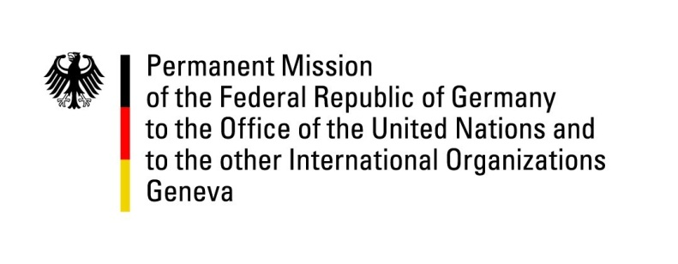

**United Nations Human Rights Council**

**44th Session of the UPR Working Group**

**Geneva, November 15, 2023**

**German Recommendations and advance questions to**

**Cuba**

Mister President,

Germany welcomes the delegation of Cuba. We commend the country for its determined dealing with the Covid-19 pandemic, as well as for the recent further improvements of the legal rights of women and girls as well as LGBTQI+ persons through Cuba’s new Family Code.

However, Germany remains deeply concerned about the human rights situation in Cuba, in particular the lack of basic civil and political rights such as the lack of freedom of assembly, opinion and press as well as the lack of independence of the judiciary.

Germany therefore recommends Cuba to:

1. Ratify without further delay the International Covenant on Civil and Political Rights, as well as the International Covenant on Economic, Social and Cultural Rights.
2. Fully cooperate with human rights mechanisms as well as civil society organizations and human rights defenders, granting them full access to Cuba, including to prisons and detention centres.
3. Release without delay all those still imprisoned over the protests of 11 July 2021 and all other political detainees.
4. Ensure freedom of assembly, of opinion and the press and create a favourable climate for independent civil society, including by adequately amending *inter alia* Articles 143 and 120 of the Cuban Penal Code.

Thank you, Mister President.

**GERMAN ADVANCE QUESTIONS TO CUBA:**

* When will Cuba ratify the International Covenant on Civil and Political Rights, as well as the International Covenant on Economic, Social and Cultural Rights?
* What concrete steps is Cuba undertaking or planning in order to ensure freedom of assembly, expression and the press as guaranteed by the Cuban constitution as well as to enhance the independence of the judiciary?
* What concrete steps is Cuba undertaking or planning in order to permit and foster the creation and activity of independent civil society organisations in Cuba?
* What practical measures is Cuba planning to protect women and girls from sexual and gender-based violence, in particular femicides, and ensure accountability for such crimes?