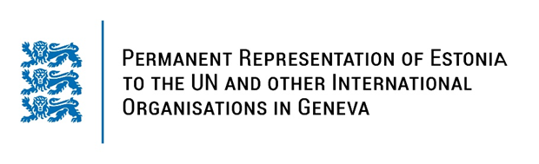

**Universal Periodic Review of Cuba**

**15 November 2023**

**Intervention by the delegation of Estonia**

Estonia welcomes the delegation of Cuba to its fourth UPR and thanks them for the national report and for the presentation today.

Estonia welcomes the adoption of the new Constitution andthe reforms undertaken. We note with appreciation the strengthening of women’s and girls’ rights, including steps taken to combat domestic violence and efforts made to improve gender equality.

We are deeply concerned about reports of aggression and harassment against journalists, activists and human rights defenders and about the repressive practices regarding the exercise of the freedom of opinion and expression, media freedom and freedom of assembly.

# In line with the previous cycle, Estonia recommends to Cuba to:

# - ratify the International Covenant on Civil and Political Rights (ICCPR) and both its optional protocols;

# - ratify the Optional Protocol to the Convention against Torture and Other Cruel, Inhuman or Degrading Treatment or Punishment;

- declare a moratorium on the use of death penalty as a first step towards eventual abolition;

- ensure everyone’s rights to freedom of opinion and expression, peaceful assembly and association and to freedom of movement, including for civil society representatives, journalists, media workers and human rights defenders.

We wish the delegation of Cuba a successful review.

Thank you.