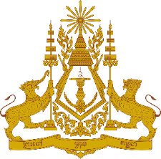

**PERMANENT MISSION OF THE KINGDOM OF CAMBODIA**

**TO THE UNITED NATIONS AT GENEVA**

**Statement of Cambodia**

At the 44th Session of the UPR Working Group

UPR of the Republic of Cuba

15 November 2023

-------

Mr. President!

1. Cambodia warmly welcomes the distinguished delegation of the Republic of Cuba and appreciates the presentation of the national report.
2. We commend efforts made by Cuban authorities in promoting human rights, achieving universal coverage in education, healthcare access, and addressing climate change despite the challenges faced.
3. In the constructive spirit, Cambodia would like to put forward two recommendations:
   1. Take additional steps to fully implement the national development plan, aiming to effectively promote economic and social development.
   2. Continue developing strategies to address climate change impacts for a more resilient society amidst escalating threats from cyclones.
4. Finally, I wish the Cuban delegation a successful review.

Thank you,

*\*\*\*\*\**