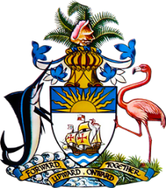

**Statement by H.E. Patricia A. Hermanns, Ambassador/Permanent Representative**  
**Permanent Mission of The Bahamas to the United Nations Office and Other International Organizations in Geneva**

**at the 44th Session of the Universal Periodic Review Working Group**  
***Presentation of National Report by the Government of Cuba***

**Wednesday 15 November, 2023**

Thank you Mr./Madam [Vice] President.

The Bahamas thanks Cuba for presenting the national report and commends wide-ranging positive developments in the field of human rights since the last review, including a robust new Constitution, enhanced cooperation with the UN human rights machinery and a strengthened legal, institutional and policy framework for promoting gender equality and women’s empowerment. As a fellow Caribbean Small Island Developing State, The Bahamas also appreciates that these take place in spite of challenges faced, including the impact of climate change.

In a constructive spirit, The Bahamas **recommends** that Cuba:

1. Fully implement the National Plan of Action to Prevent and Combat Trafficking in Persons and Protect Victims

and

1. Continue efforts to eliminate gender stereotypes in Cuban society, including through awareness-raising campaigns

We wish Cuba a successful review process.

I thank you.