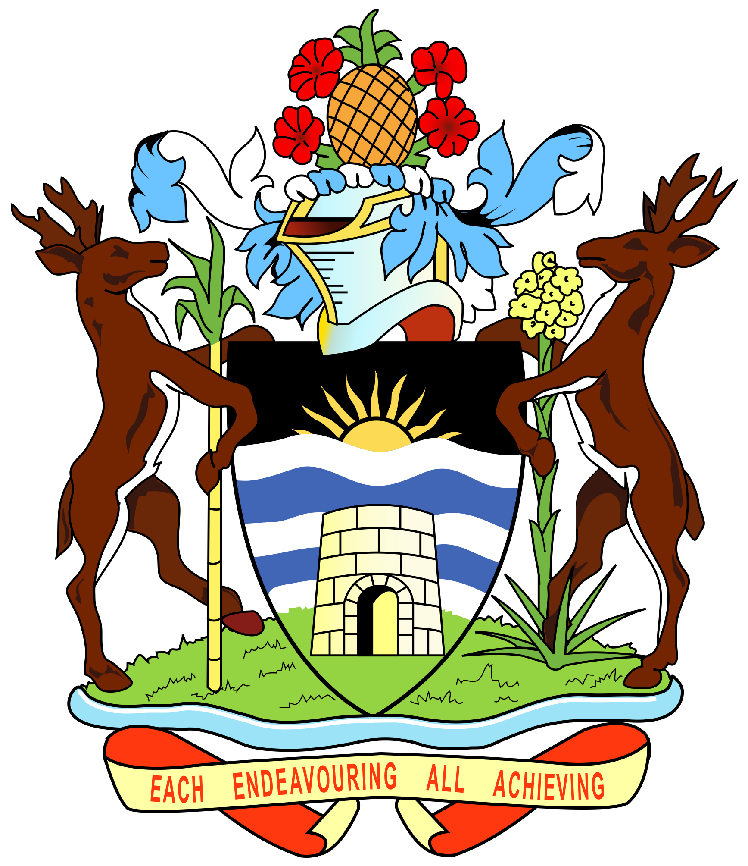

**GOVERNMENT OF ANTIGUA AND BARBUDA**

**44th Session of the Working Group on the Universal Periodic Review**

**UPR of the Republic of Cuba - 15.11.2023**

Thank you, Mr. President.

Antigua and Barbuda warmly welcomes the distinguished delegation of the Republic of Cuba for the fourth cycle of UPR and extends our gratitude for the presentation of the national report. We commend Cuba for its diligent efforts in promoting human rights at the national level, particularly with regards to the Convention against Torture and the Criminal Procedure Act of 2021, which focuses on strengthening due process guarantees.

In the spirit of constructive engagement, Antigua and Barbuda would like to propose the following recommendations to Cuba:

1. Enhance efforts to prosecute traffickers and establish the necessary legal framework and procedures to protect victims of trafficking and witnesses. By prioritizing the prosecution of traffickers, Cuba can ensure that justice is served and that vulnerable individuals are provided with the necessary support system.

2. Introduce at least one year of compulsory pre-primary education and consider extending compulsory education to cover at least nine years of primary and secondary education. Education is a fundamental human right, and by increasing the duration of compulsory education, Cuba can ensure that all children have access to quality education from an early age, laying a strong foundation for their future development.

3. Adopt specific legislation and strategies that reflect a gender perspective and intersectionality, promoting an inclusive environment that facilitates the participation of women with disabilities. By recognizing the unique challenges faced by women with disabilities, Cuba can work towards creating an inclusive society that ensures equal opportunities and support for all women, irrespective of their disabilities.

We sincerely hope that Cuba will take these recommendations into consideration and incorporate them into its national policies and programs. We believe that by doing so, Cuba will further strengthen its commitment to upholding and promoting human rights.

Once again, we wish Cuba a successful review. Thank you, Mr. President.