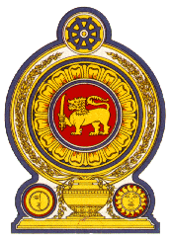

**44th Session of the Universal Periodic Review**

**Review of Colombia**

**07 November 2023**

**Statement by the Democratic Socialist Republic of Sri Lanka**

Mr President,

Sri Lanka welcomes the delegation of Colombia and appreciates their presentation.

We appreciate the measures taken by Colombia since its last UPR in the area of human rights, including amendments to the Constitution to strengthen the judicial system and institutional improvements to implement the 2014-2034 National Human Rights Strategy.

In a constructive spirit, Sri Lanka recommends Colombia;

-To advance measures to eliminate discrimination against women.

-To enhance adequate access to health and education services for all children including the children of migrants.

We wish Colombia all the success in its UPR engagement.