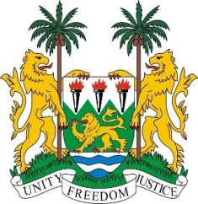

**SIERRA LEONE**

**44th Session of the UPR**

**COLUMBIA**

Tuesday, 7th November, 2023

**Check against Delivery**

**Mr. Vice President**,

Sierra Leone welcomes **Ms. Elizabeth Inés TAYLOR JAY, Vice-Minister of Multilateral Affairs - Ministry of Foreign Affairs** and the distinguished high-level delegation from Columbia and thanks it for the presentation of its national report.

My delegation welcomes the bilateral ceasefire of 22 August 2023 with the National Liberation Army and welcomes the formation and important work of the Comprehensive System of Truth, Justice, Reparation and Non-Repetition. As a post-conflict country, Sierra Leone fully supports Colombia in its request for international assistance and cooperation to support the work of the Comprehensive System in the search for peace, justice and reparation for human rights victims.

In a spirit of constructive engagement, we recommend that Colombia consider the following:

1. Extend a standing invitation to all special procedures mandate holders and facilitate their access to the country.
2. Amend the relevant law by raising the legal age of marriage, even with parental consent, in order to prevent child marriage.
3. Support the autonomous and independent work of the Comprehensive System of Truth, Justice, Reparation and Non-Repetition.
4. Continue efforts to implement the provisions of all signed peace agreements.

Sierra Leone wishes Colombia every success in the completion of its fourth review cycle.

I thank you.