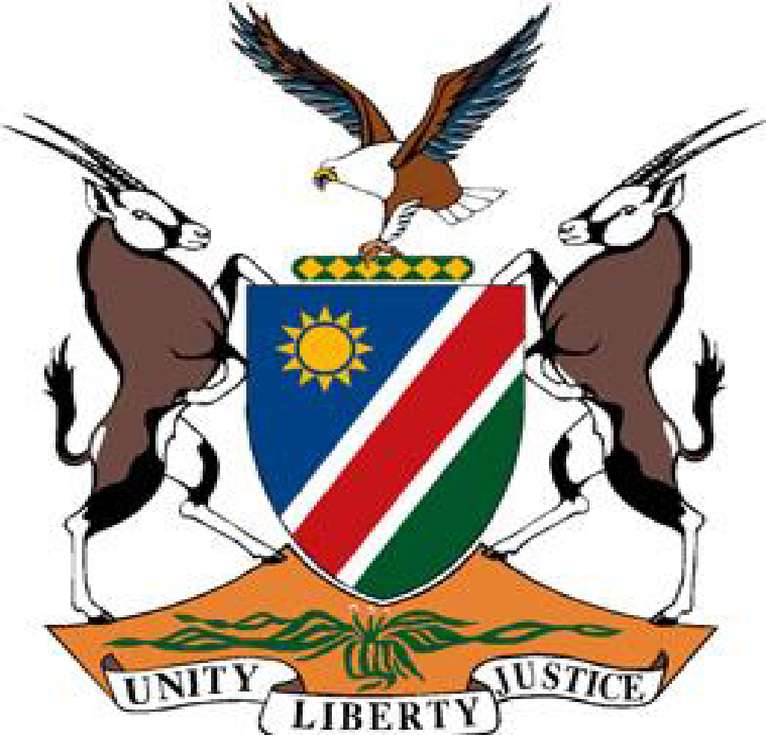

Statement by Ms. Xungileni Chitundu, Fourth UPR Cycle of Columbia, 07 November 2023.

1. **Thank you, Mr. President,**
2. Namibia warmly welcomes the Esteemed Delegation of Columbia to to the fourth cycle of the Universal Periodic Review. We thank them for submitting a comprehensive national report and for their unwavering commitment to the UPR process.
3. Namibia has taken note with appreciation of the positive human rights impact measures taken by Columbia during the period under review. Among the measures that have found our admiration are the peacebuilding efforts of Columbia, including the provision of significant financial resources for the effective operationalisation of the comprehensive system of truth, justice, reparation and non-repetition put in place by the Columbian Government.
4. In the spirit of constructive dialogue Namibia recommends the following for consideration by Columbia:
5. Ratify the Optional Protocol to the Convention on the Rights of Persons with Disabilities; and
6. Ratify the Inter-American Convention against Racism, Racial Discrimination and Related Forms of Intolerance.
7. We wish the delegation of Columbia a successful review.
8. **I thank you Mr. President.**