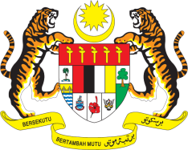

**STATEMENT BY MALAYSIA**

**REVIEW OF COLOMBIA**

**44TH SESSION OF THE UPR WORKING GROUP**

**6 – 17 NOVEMBER 2023**

Malaysia thanks Colombia for the presentation of its national report.

1. Malaysia commends Colombia for its commitment in strengthening its capacities in the field of human rights including by amending legislation to harmonise the national legal framework with international obligations.
2. In the spirit of constructive engagement, Malaysia **recommends** the following:

3.1 Step up efforts in developing a coordinating mechanism to manage the cross-sectoral response of entities responsible for ensuring the prevention of violence against women, as well as support and access to justice using information systems for victims;

3.2 Continue to implement steps to prevent the recruitment and exploitation of children and adolescents by illegal armed groups and organised criminal groups, including by strengthening local capacities for countering, reducing and eliminating risk factors and the threat of recruitment; and

3.3 Continue to implement the National Human Rights Education Plan to strengthen accessibility to schools and increase the quality of education in rural areas.

1. We wish Colombia a successful UPR.

Thank you.

**7 NOVEMBER 2023**

**GENEVA**