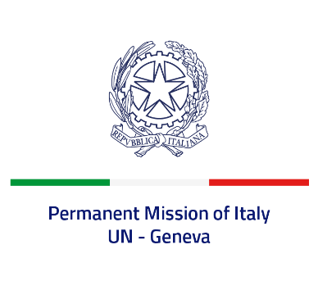

*Check against delivery*

**UPR 44 - Colombia**

**Tuesday 7 November 2023, 14:30 - 18:00**

**Delivered by: Ambassador Vincenzo Grassi, Permanent Representative of Italy**

*(Focal point: Angela Zanca, First Secretary)*

Thank you, Mister President.

We thank the distinguished delegation of Colombia for the presentation.

Italy recognizes the steps taken by Colombia since its last UPR, including the establishment of a new Ministry of Equality and Equity, as well as the development of an action plan to implement the Security Council Resolution 1325 on Women, Peace and Security.

We also welcome the endorsement by Colombia of the Safe Schools Declaration and look forward to the initiation of the ratification process of the Optional Protocol to the Convention against Torture.

Italy seizes this opportunity to offer Colombia the following recommendations:

* *Continue the implementation of the Final Peace Agreement and the recommendations of the Commission for the Clarification of Truth, Coexistence and Non-Repetition;*
* *Proceed with the reform of the National Police and enhance training on human rights for the members of the “Public Force”;*
* *Ensure effective protection of human rights defenders as well as of persons belonging to minorities and Indigenous Peoples;*
* *Step up efforts to protect the civilian population in the territories most affected by violence and to prevent the grave violations against children, including their recruitment and exploitation by non-state armed groups and criminal organisations.*

We wish Colombia a successful review.

I thank you.