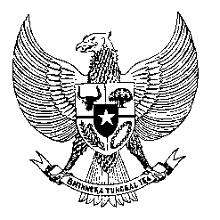

Permanent Mission

of the Republic of Indonesia to the UN, WTO,

and Other International Organizations

in Geneva

**STATEMENT BY THE DELEGATION OF THE REPUBLIC OF INDONESIA**

**AT THE 44th SESSION OF THE UPR WORKING GROUP**

**CONSIDERATION OF THE UPR REPORT OF COLOMBIA**

**7 NOVEMBER 2023**

**Thank you, Mr. Vice-President**

Indonesia thanks the delegation of Colombia for their report.

We welcome efforts made by the Government of Colombia with a view to ratifying the Optional Protocol to the Convention against Torture and Other Cruel, Inhuman or Degrading Treatment or Punishment (OPCAT) and the Optional Protocol to the Convention on the Rights of Persons with Disabilities (OPCRPD).

We also appreciate various measures that have been adopted to seriously prevent and combat trafficking in persons in Colombia to protect its citizens from the scourge of this crime.

In a constructive spirit to support the full realization of human rights in Colombia, Indonesia recommends to:

1. Ensure the full implementation of the Framework Plan for Implementation of the Final Peace Agreement, including in the areas of transitional justice, reintegration of former combatants and reparation of victims.
2. Continue efforts to improve access to justice and support provision for victims of gender-based violence, especially women and children.
3. Take further measures to increase access of persons with disabilities to health care, education system and labor market.

Finally, we wish the Colombian delegation a very successful review.

Thank you.

*Word Count: 188 words*

*Max. Speaking Time: 1 minute 25 seconds*