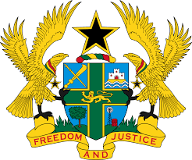

**STATEMENT BY GHANA DELIVERED BY ABA AYEBI-ARTHUR,**

**MINISTER- COUNSELLOR, DURING THE 44TH SESSION OF THE**

**UPR WORKING GROUP ON TUESDAY, 7TH NOVEMBER 2023**

**UNIVERSAL PERIODIC REVIEW OF COLOMBIA**

Mr. Vice President

Ghana welcomes the delegation of Colombia to the UPR and thanks them for the oral update.

We welcome the drafting of a road map for the establishment of a national human rights action plan, aimed at reinforcing the implementation of concrete action to improve the effective enjoyment of human rights in Colombia. We also acknowledge the positive efforts being made by the Government to progressively implement the National Human Rights Strategy (2014–2034).

My delegation further commends the necessary strategies undertaken by the Government towards achieving gender equality and equity, such as strengthening the legal and institutional framework, ensuring women’s increased participation in decision making and implementing training and awareness-raising strategies to counter machismo.

In the spirit of constructive dialogue, Ghana wishes to make the following recommendations to Colombia:

1. **To redouble efforts in protecting migrants, especially indigenous peoples and communities of African descent;**
2. **Intensify efforts to prevent and address femicide and take all necessary steps to provide justice to the victims.; and**
3. **Intensify efforts to ratify the OP-CAT.**

We wish Colombia every success with the review process.

I thank you.