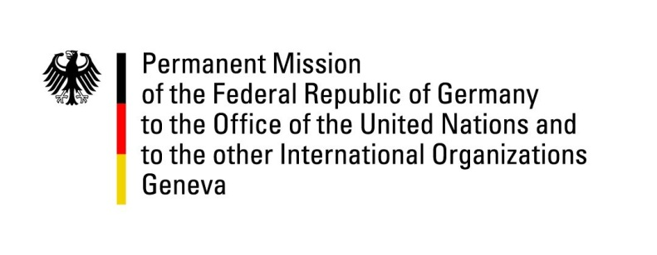

**United Nations Human Rights Council**

**44th Session of the UPR Working Group**

**Geneva, 7th of November 2023**

**German Recommendations and advance questions to**

**Colombia**

Mister President,

Germany welcomes the delegation of Colombia.

Germany commends Colombia for its strong efforts to improve the domestic human rights situation through comprehensive peace policies, and for advancing the implementation of the 2016 peace agreement, including in transitional justice.

However, Germany remains concerned about the challenges Colombia faces in preventing and protecting against human rights violations and abuses, especially in remote areas characterized by poverty, armed groups and weak state capacity.

Germany recommends Colombia to:

* Increase efforts to prevent attacks against human rights defenders and community leaders, inter alia by implementing Decree 660 of 2018 (*on collective protection for organizations and communities*) and by strengthening self-protection mechanisms of indigenous and other ethnic communities.
* Take effective measures to fight impunity for violations of human rights in the ordinary justice system, inter alia by increasing the presence and capacity of judicial police officers, prosecutors and judges in remote areas and further strengthening specialized units to dismantle organized armed and criminal groups and their support networks.
* Implement the comprehensive rural reform, so as to improve economic, social and cultural rights and address drivers of conflict.
* Enhance prevention and protection mechanisms against forced recruitment of minors.

Thank you, Mister President.

**GERMAN ADVANCE QUESTIONS TO COLOMBIA:**

* Which steps is Colombia taking to prevent and protect against gender-based and sexual violence, especially against women and girls, but also LGBTQI persons?
* Which steps is Colombia taking to ensure that the rights of migrants and refugees crossing the country are protected, especially against organized armed and criminal groups engaged in human trafficking?
* Does Colombia intend to ratify the Optional Protocols to the Convention against Torture and Other Cruel, Inhuman or Degrading Treatment or Punishment and to the Convention on the Rights of the Child on a communications procedure?