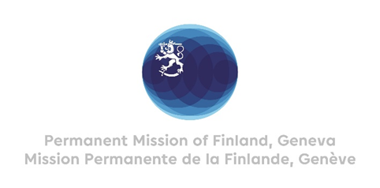

**44 Session of the UPR working group**

**Recommendations by Finland to Colombia**

**7th November 2023**

Mr. President,

Finland welcomes the engagement of Colombia in the UPR. We recognize the Government’s actions regarding human rights defenders, prevention of gender -based violence and recruitment of children.

Finland recommends the following:

First, improve **protection of human rights defenders and social leaders** by ensuring that judicial authorities conduct a prompt and impartial investigation on violations against human rights defenders and advance investigations of these crimes.

Second, strengthen urgently measures to **prevent the forced recruitment, exploitation and sexual violence against children and adolescents by armed groups**.

Third, **ensure that victims of gender-based violence, especially indigenous and Afro-Colombian women, girls and adolescents have access to justice, medical treatment and mental health care** and strengthen the legislative framework on gender -based violence.

Finland wishes Colombia a successful UPR review.

Thank you.