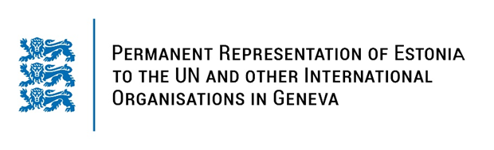

**Universal Periodic Review of Colombia**

**7 November 2023**

**Intervention by the delegation of Estonia**

Estonia warmly welcomes the delegation of Colombia to its fourth UPR. We thank Colombia for its national report and the information provided today.

Estonia welcomes the steps undertaken to achieve peace, particularly the adoption of comprehensive legislation to implement the Final Agreement for Ending the Conflict and Building a Stable and Lasting Peace Agreement, and encourages Colombia to continue its efforts to implement the agreements.

Estonia notes with appreciation the extension of the presence of the Office of the United Nations High Commissioner for Human Rights in Bogota until 2032.

Estonia would like to offer the following recommendations to Colombia:

- implement policies and programmes ensuring the enforceability of abortion rights recognised by the Constitutional Court, including measures to eliminate discrimination in access to abortion services;

- take further measures to reduce the gender inequalities, including by conducting inclusive awareness-raising campaigns on the principles of non-discrimination and gender equality;

- review the national regulatory and legal framework on gender-based violence to improve the mechanism of prevention and protection of victims;

- decriminalize defamation and include it in the Civil Code in line with international standards;

- ratify the Optional Protocol to the Convention against Torture and Other Cruel, Inhuman or Degrading Treatment or Punishment (OP-CAT).

Estonia wishes to the delegation of Columbia all success in the current review and in implementing the recommendations.

Thank you.