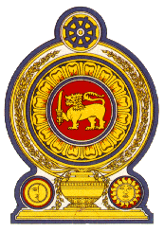

44th Session of the Universal Periodic Review

**Review of Cameroon** – 14th November 2023

Statement by the Democratic Socialist Republic of Sri Lanka

Mr. President,

Sri Lanka warmly welcomes the delegation of Cameroon and appreciates the presentation made.

Sri Lanka commends the measures taken by Cameroon since its last UPR towards strengthening the respect for human rights training, regular capacity development and institutional coordination in the area of Human Rights through an Inter-ministerial Committee.

In a constructive spirit, Sri Lanka recommends that Cameroon;

1. Continues efforts to provide access to education at all levels by developing school infrastructure, granting subsidies to private schools, providing teaching aids and school textbooks, and consolidating staff strength.
2. Ensure access to health-care services through the implementation of the National Digital Health Strategic Plan- (2020-2024) to improve the accessibility and quality of healthcare and services through the use of digital technologies.
3. Take measures to strengthen support for women experiencing mental health concerns as a result of domestic violence in the form of long-term counseling, affordable housing, childcare support, legal assistance, and employment opportunities.

We wish Cameroon success in its UPR engagement.