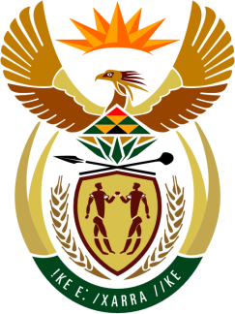

**SOUTH AFRICAN PERMANENT MISSION**

**TO THE UNITED NATIONS**

**AND OTHER INTERNATIONAL ORGANISATIONS**

**44TH SESSION OF THE WORKING GROUP ON THE**

**UNIVERSAL PERIODIC REVIEW**

**Review of CAMEROON**

**14 NOVEMBER 2023**

**(65 Seconds)**

**speaker no: 101**

***Check against delivery***

Mr. President,

South Africa welcomes the distinguished delegation of Cameroon to this UPR Session under the fourth cycle.

My delegation commends Cameroon for its recent ratification, in September 2023, of the United Nations Convention on the Rights of Persons with Disabilities as well as the Protocol to the African Charter on Human and Peoples’ Rights on the Rights of Persons with Disabilities.

In order to ensure progress in promoting and protecting human rights, South Africa wishes to respectfully recommend that Cameroon:

1. Increase efforts to combat sexual and gender-based violence, including by prioritising social and medical support to victims,
2. Enhance measures to prevent discrimination against all vulnerable groups, including women, children, persons living with HIV/AIDS, persons from the LGBTQ+ community and ethnic minorities.
3. Consider harmonisation of criminal and civil legislation on the minimum age for marriage, for both girls and boys, with international standards.

South Africa wishes Cameroon a successful review.

I thank you.