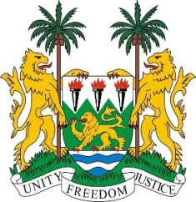

**SIERRA LEONE**

**44th Session of the UPR**

**CAMEROON STATEMENT**

Tuesday, 14th November 2023

**Check against delivery**

**Mr. President**,

Sierra Leone welcomes and thanks **H.E Mr. Lejeune Mbella Mbella Minister of Foreign Affairs** and the distinguished high-level delegation of Cameroon and thanks them for the presentation of its national report.

We commend Cameroon for the conduct of the Major National Dialogue between the government and various opposition parties, aimed at resolving the Anglophone Crisis. We note that the dialogue also attracted people from other regions of the country. We further commend the government for the establishment of the National Disarmament, Demobilization and Reintegration Committee for ex-combatants and armed groups in the North-West and South-West of the country.

To further support Cameroon's ongoing efforts, Sierra Leone offers the following recommendations:

1. Continue to adopt peaceful approach to addressing conflict and to build and strengthen transitional justice mechanisms in the country.
2. Adopt a holistic and inclusive approach in addressing the root causes of the conflict in the affected regions of Cameroon, ensuring a comprehensive strategy for sustainable peace.
3. Consider establishing a Peace and Reconciliation Committee aimed at addressing grievances stemming from the conflict and fostering long-lasting peace.

Sierra Leone wishes the sister Republic of Cameroon every success in the completion of its fourth review cycle.

Thank you, Mr. President.