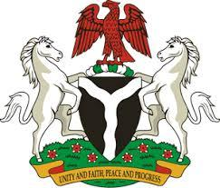

*Please check against delivery*

**HUMAN RIGHTS COUNCIL**

**44TH SESSION OF THE WORKING GROUP OF THE UPR OF THE REPUBLIC OF CAMEROON**

**STATEMENT BY NIGERIA**

**14TH NOVEMBER, 2023**

**Mr. President,**

Nigeria welcomes the delegation of the brotherly Republic of Cameroun to the presentation of its National Report and commends the Government for its commitment to international human rights obligations and continued cooperation with human rights mechanisms.

2. My delegation applauds the Government of Cameroun for the efforts towards the reduction of Maternal and Child Mortality, especially in the implementation of “The Maternal, Neonatal, and Child Support Project.”

3. While recognizing various efforts and commitments of the Government of Cameroun to promote and protect human rights, Nigeria recommends the following for consideration by Cameroun:

1. To strengthen efforts by adopting and implementing a national action plan to combat trafficking in persons and allocate sufficient resources for implementation and regular evaluation; and
2. To redouble efforts and commitment, as well as seek necessary international support to enhance its capacity to promote and protect human rights.

4. We wish Cameroun a very successful review process.

I thank you, Mr. President.