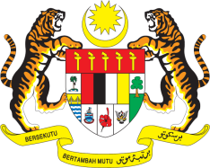

**STATEMENT BY MALAYSIA**

**REVIEW OF CAMEROON**

**44TH SESSION OF THE UPR WORKING GROUP**

**6 – 17 NOVEMBER 2023**

Malaysia commends Cameroon’s recent ratification of the United Nations Convention on the Rights of Persons with Disabilities.

1. On this positive note, Malaysia **recommends** the following:

2.1 Continue to strengthen the country’s education agenda, by implementing free secondary education without gender discrimination;

2.2 Improve quality of education infrastructures and curriculum in rural areas to provide better education access to indigenous and internally displaced children; and

2.3 Continue to provide a safe and secure public healthcare services for all.

1. We wish Cameron a successful review.

Thank you.

**14 NOVEMBER 2023**

**GENEVA**