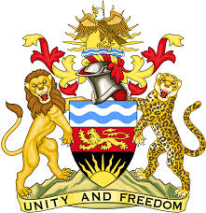

**REPUBLIC OF MALAWI**

**MALAWI STATEMENT ON THE REPUBLIC OF CAMEROON UNIVERSAL PERIODIC REVIEW**

**TUESDAY, 14TH NOVEMBER 2023**

**Mr. President**,

Malawi welcomes Cameroon to this review and thanks the delegation for the comprehensive presentation.

Malawi takes note of the steps taken in the promotion and protection of human rights through the ratification of human rights instruments such as the United Nations Convention on the Rights of Persons with Disabilities and the Protocol to the African Charter on Human and Peoples’ Rights on the Rights of Persons with Disabilities.

In the spirit of constructive dialogue, Malawi makes the following recommendations to Cameroon:

1. Continue implementing policies to increase the number of women in politics and other decision-making positions;
2. Take all measures to eradicate child, early and forced marriages.
3. Consider ratification of outstanding international human rights instruments, in line with the country’s national priorities

We wish Cameroon all the best at this review and in the implementation of the recommendations.

**Thank you, Mr. President**.